John Michael Go
Career Entry Level Java Programming
Date: Jan. 11, 2013

DAY 1

Program Name: Payroll1

Objective: Program calculates monthly salary with absences and monthly deductions.

Algorithm:

- User inputs name.
- User inputs dept.
- User inputs days absent
- Program outputs Salary details, deductions and Salary computation.

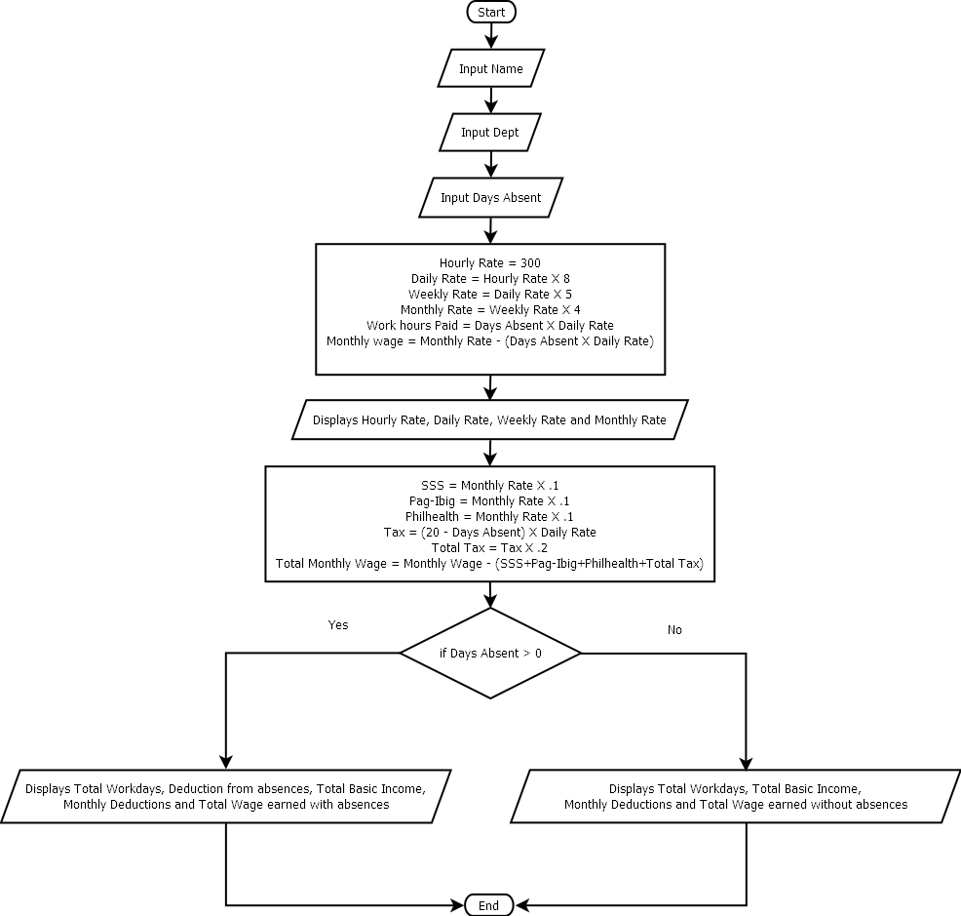
Flowchart:
Pseudocode:

import java.util.*;

public class Payroll1{

static Scanner console = new Scanner (System.in);

public static void main(String[]args){

// variable declaration
String name, dept;
int abs, hour;
double day, week, month, wage, sss, pbg, tax, ttax, phl, twage, tabs;

// inputs name, dept and absent
System.out.println ("");
System.out.print("Enter your name: ");
name = console.next();
System.out.println ("");
System.out.print("Enter your dept: ");
dept = console.next();
System.out.println ("");
System.out.print("Days absent: ");
abs = console.nextInt();
System.out.println("");

// hourly, daily, weekly, monthly and total wage computation
hour = 300;
day = hour * 8;
week = day * 5;
month = week * 4;
tabs = abs*day;
wage = month - (abs*day);
System.out.println("");
System.out.println ("===============================================================================");

// displays employee details
System.out.println("");
System.out.println("Employee Details:");
System.out.println("");
System.out.println("Name : " +name);
System.out.println("Dept.: " +dept);
System.out.println("");

// displays salary details
System.out.println("Salary Details:");
System.out.println("");
System.out.println("Your Hourly Rate is : 300.00");
System.out.println("Your Daily Rate is : " + String.format("%.2f", day));
System.out.println("Your Weekly Rate is : " + String.format("%.2f", week));
System.out.println("Your Monthly Rate is : " + String.format("%.2f", month));

// computation of deductions
sss = month * .10;
pbg = month * .10;
phl = month * .10;
tax = ((20-abs) * day);
ttax = tax * .20;
twage = wage - (pbg+sss+phl+ttax);

// displays deductions
System.out.println("");
System.out.println("Deductions:");
System.out.println("");
if (abs > 0){
System.out.println("SSS : " + String.format("%.2f", sss));
System.out.println("Pag-Ibig : " + String.format("%.2f", pbg));
System.out.println("Witholding Tax less " + abs + " absence/s : " + String.format("%.2f", ttax));
System.out.println("Philhealth : " + String.format("%.2f", phl));
System.out.println ("");
System.out.println(
"===============================================================================");

// displays overall salary computation with absences
System.out.println ("");
System.out.println("Salary Computation:");
System.out.println ("");
System.out.println ("Your Total Workday/s in a Month : " +(20-abs));
System.out.println ("");
System.out.println("Deduction from " + abs + " absence/s : " + String.format("%.2f", tabs));
System.out.println ("");
System.out.println("Your Total Basic Income : " + String.format("%.2f", wage));
System.out.println ("");
System.out.println("Less Monthly Deductions : " + String.format("%.2f", (pbg+sss+phl+ttax)));
System.out.println ("");
System.out.println("Your Total Wage with Absence/s : " + String.format("%.2f", twage));
System.out.println ("");
System.out.println(
"===============================================================================");
System.out.println ("");
System.out.println ("");
System.out.println ("");

// displays deductions
}else{
System.out.println("SSS : " + String.format("%.2f", sss));
System.out.println("Pag-Ibig : " + String.format("%.2f", pbg));
System.out.println("Witholding Tax : " + String.format("%.2f", ttax));
System.out.println("Philhealth : " + String.format("%.2f", phl));
System.out.println ("");
System.out.println(
"===============================================================================");

// displays overall salary computation without absences
System.out.println ("");
System.out.println("Salary Computation:");
System.out.println ("");
System.out.println ("Your Total Workday/s in a Month : " +(20-abs));
System.out.println ("");
System.out.println("Your Total Basic Income : " + String.format("%.2f", wage));
System.out.println ("");
System.out.println("Less Monthly Deductions : " + String.format("%.2f", (pbg+sss+phl+ttax)));
System.out.println ("");
System.out.println("Your Total Wage : " + String.format("%.2f", twage));
System.out.println ("");
System.out.println (
"===============================================================================");
System.out.println ("");
System.out.println ("");
System.out.println ("");
}

}

}

Screenshot:

